CREATE TABLE EventPlanLine

(

PlanNo VARCHAR2(8) CONSTRAINT PlanNo1NotNull NOT NULL,

LineNo NUMBER(2) CONSTRAINT LineNoNotNull NOT NULL,

TimeStart DATE CONSTRAINT TimeStartNotNull NOT NULL,

TimeEnd DATE CONSTRAINT TimeEndNotNull NOT NULL,

NumberFId NUMBER(2),

LocNo VARCHAR2(8) CONSTRAINT Loc1NoNotNull NOT NULL,

ResNo VARCHAR2(8) CONSTRAINT ResNoNotNull NOT NULL,

CONSTRAINT PK_EventPlanLine1 PRIMARY KEY (PlanNo, LineNo),

CONSTRAINT FK_Plan1N0 FOREIGN KEY (PlanNo) REFERENCES EventPlan (PlanNo),

CONSTRAINT FK_Loc2N0 FOREIGN KEY (LocNo) REFERENCES LOCATION (LocNo),

CONSTRAINT FK_RES2N0 FOREIGN KEY (ResNo) REFERENCES RESOURCETBL (ResNo)

) ;

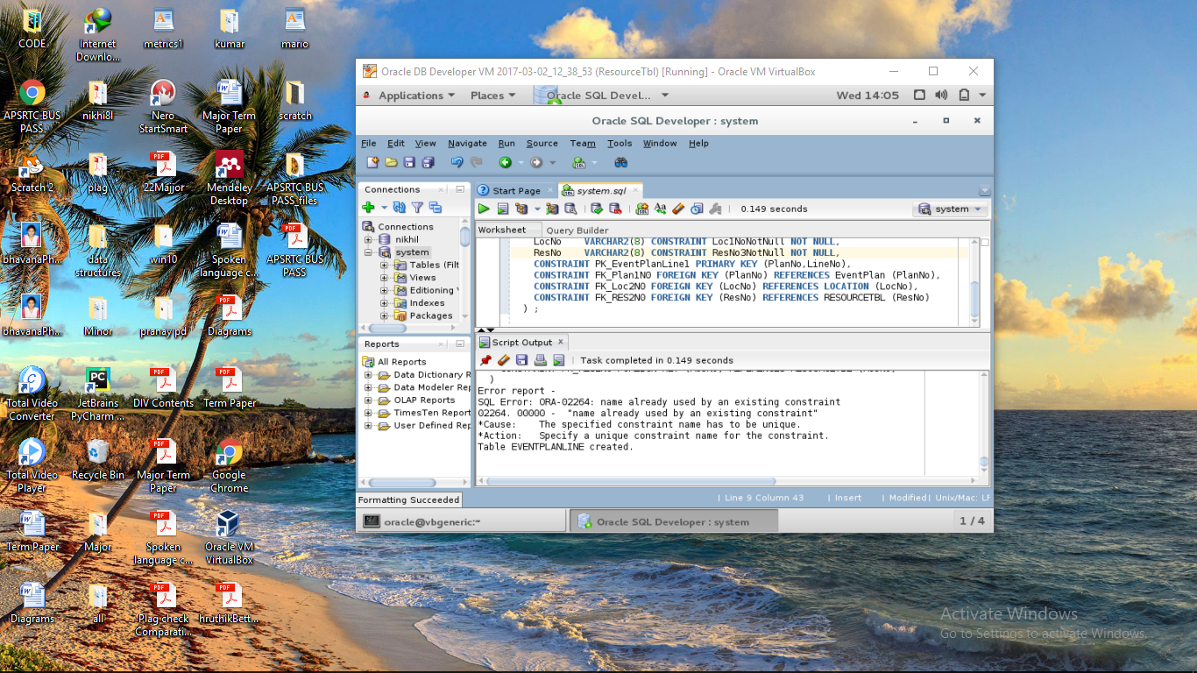

Select * from eventplanline;

